Lab 4: Processes and grep

- Answer all of the following questions. Questions are given in bold italics.
- Save all your answers in a file named YourFirstNameYourLastName.doc (or the appropriate file extension).
- Upload this file to Blackboard.

- Create a directory called Lab4 in your home directory.

Note: Remember Linux is case sensitive.
What is the command you used to create this directory?
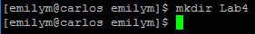

- Run the ps command.

Explain what each of the four columns mean.
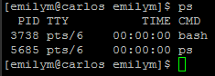
PID = process Id of the process
TIME = the cumulative CPU time
TTY = controlling terminal
CMD = command with all its arguments

- Run the command sleep 10.

Explain what happens.
This stops the user from inputting commands for 10 seconds.

- Run the command sleep 10 &.

Explain what happens. Why?
How will you know when it is complete?

This causes the process sleep 10 to run in the background and the shell will return control to the user.

- Start a background process which sleeps for 1000 seconds.
List the running processes to confirm it is running in the background. Terminate the sleeping process.
List the running processes to confirm the sleeping process has been terminated.

State the four commands you used.
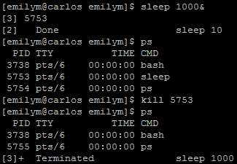

Use the file /macbeth.txt for the following questions. (Reminder: this file is located in the root directory). This file contains the full text of Shakespeare’s Macbeth.

- Using the grep command, find and print to screen all sentences containing the word “unwiped” in the file /macbeth.txt.

List the single grep command you used and the sentence(s) returned.
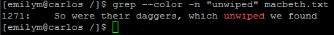

- Repeat the above but also print the line numbers of the sentence(s) containing “unwiped”.

List the single grep command you used and the sentences (with line numbers) containing “unwiped”.

- Create a file lady.txt in your Lab4 directory containing all sentences containing the whole word “lady” in the file /macbeth.txt.

Tip: use the grep command and redirection (see Lab 2 slides).
What was the command you ran? Check the contents of your file is the same as /lady.txt.

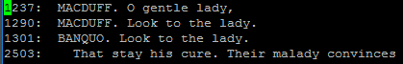

- Using grep, count the number of occurrences of the whole word “witch” in the file /macbeth.txt (case sensitive).

What was the command you ran? How many sentences contained the whole word witch?
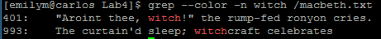

- Using grep, count the number of occurrences of the whole word “witch” in the file /macbeth.txt (case insensitive).

What was the command you ran? How many sentences contained the whole word witch (case insensitive)?
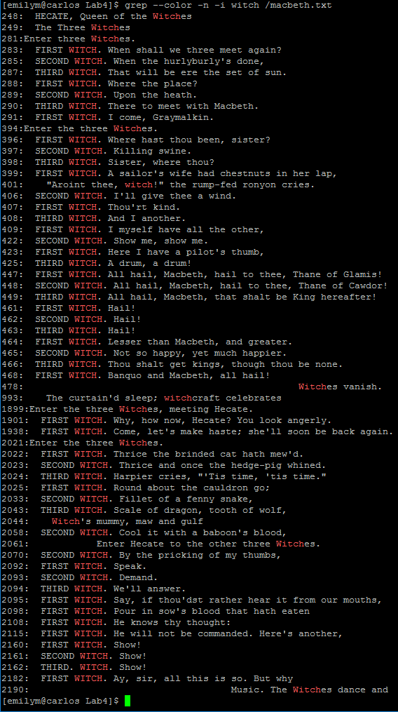
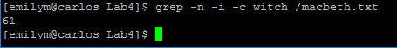

11. Using grep, list all sentences that start with “Dun” in the file /macbeth.txt.

What command did you use? (Tip: use a regular expression)
